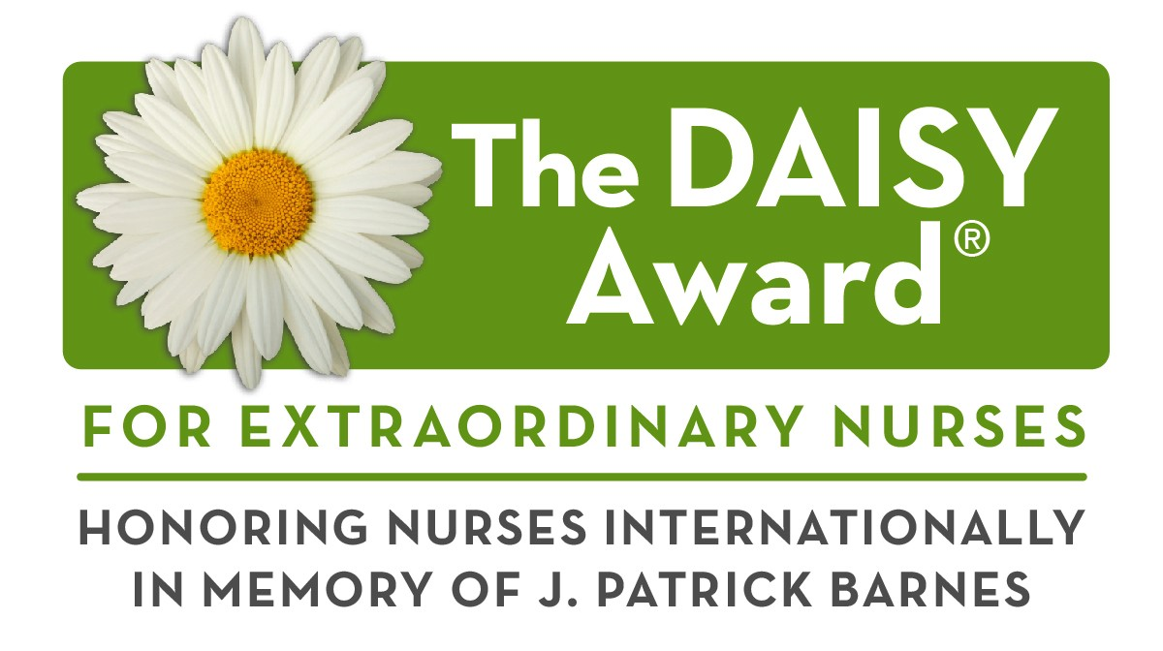

Want to Say Thank You to Your Nurse?

**Share *Your* Story!**

The DAISY (Diseases Attacking the Immune SYstem) Award is an international recognition program that honors and celebrates the skillful, compassionate care nurses provide every day. The DAISY Foundation was established by the family of J. Patrick Barnes after he died from complications of the auto-immune disease ITP in 1999. During his hospitalization, they deeply appreciated the care and compassion shown to Patrick and his entire family. When he died, they felt compelled to say “thank you” to nurses in a very public way. Please say thank you by sharing **your** story of how a nurse made a difference you will never forget!

I would like to thank my nurse (name): ____________________________________.

**Please share your story of why your nurse is so special, providing as much detail as possible.**

**(More space & selection criteria provided on p. 2.)**

Thank you for taking the time to nominate an extraordinary nurse for this award! We’d love to include you in the celebration if your nurse is selected for a DAISY Award. Please tell us a little about yourself.

Your name

Phone I am (please select one):

Date of nomination Email

Patient Family/Visitor RN MD Staff Volunteer



**Please submit your nomination form to:**

Shannan Hempler, HR, Norton County Hospital

Email: [shempler@ntcohosp.com](mailto:shempler@ntcohosp.com) Phone: 785-877-3351

Phone

© DAISY Foundation

______________________________________________________________

______________________________________________________________

______________________________________________________________

______________________________________________________________

______________________________________________________________

______________________________________________________________

______________________________________________________________

______________________________________________________________

______________________________________________________________

______________________________________________________________

______________________________________________________________

______________________________________________________________

______________________________________________________________

______________________________________________________________

______________________________________________________________

______________________________________________________________

______________________________________________________________

______________________________________________________________

______________________________________________________________

______________________________________________________________

______________________________________________________________

**To win the DAISY Award, the nominated individual must be a licensed nurse (RN, LPN or Advanced Practice Nurse).**

**If a CNA is nominated, he or she will still be recognized for the nomination, even though CNAs are ineligible to receive the DAISY Award.**

**Judges will look for the following criteria when scoring nominations:**

* They must be truthful, honest and fair.
* They must place the patient at the center of all they do.
* They must demonstrate leadership and team work qualities.
* They must provide the highest quality of care possible.
* They must listen intentionally.
* They must have a learning mindset.

**If you have any questions, please contact Shannan Hempler at** [**shempler@ntcohosp.com**](mailto:shempler@ntcohosp.com) **or 785-877-3351.**